**Guide to setting up the JDK in Eclipse.**

**Note-** Once we install eclipse on our computer, we need to specify the location of our JDK (Java Development Kit) in Eclipse because otherwise, Eclipse will take JRE (Java Runtime Edition). We will go over the difference between JDK and JRE later in this course. This guide was prepared using Eclipse on Windows. For macOS users, equivalent steps have to be performed.

1. Navigate into the directory structure created when you unzipped Eclipse, look for the file called *eclipse.exe* and run it. It would be convenient to make a direct access icon on your computer’s desktop to execute this file directly from the desktop. Once Eclipse is loaded, we will get the following window.

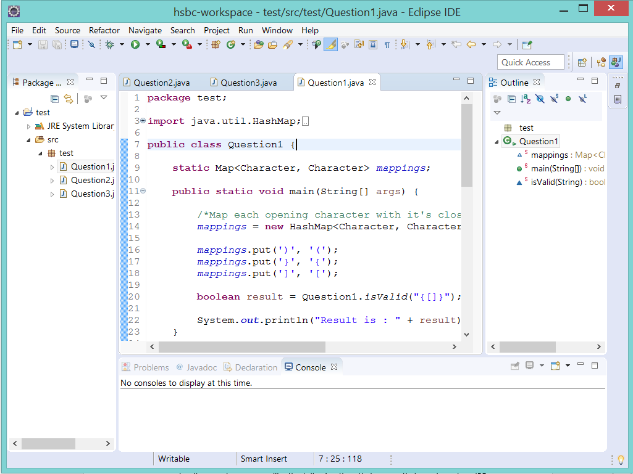

1. From the Eclipse menu, go to Window/Preferences. The “Preferences” window will pop up. See next page.

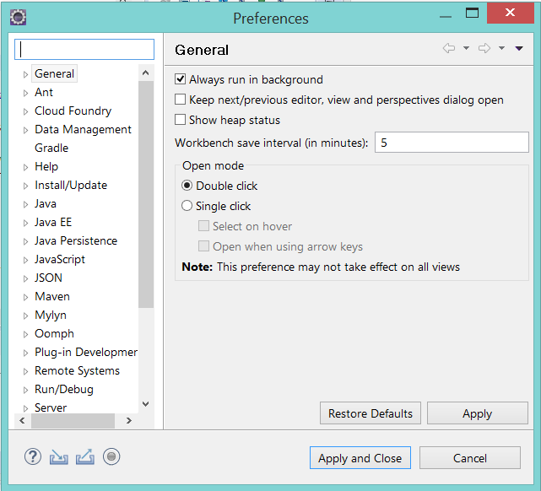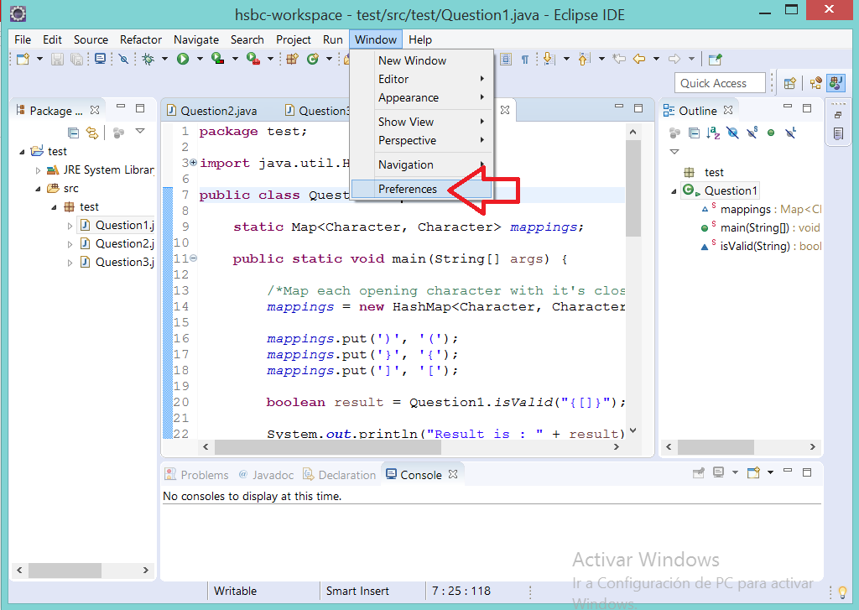

1. Within the Preferences Window, go to Java/Installed JREs. You will see that the JRE is the default. Next, we need to remove that configuration and set up JDK as our default Java definition.

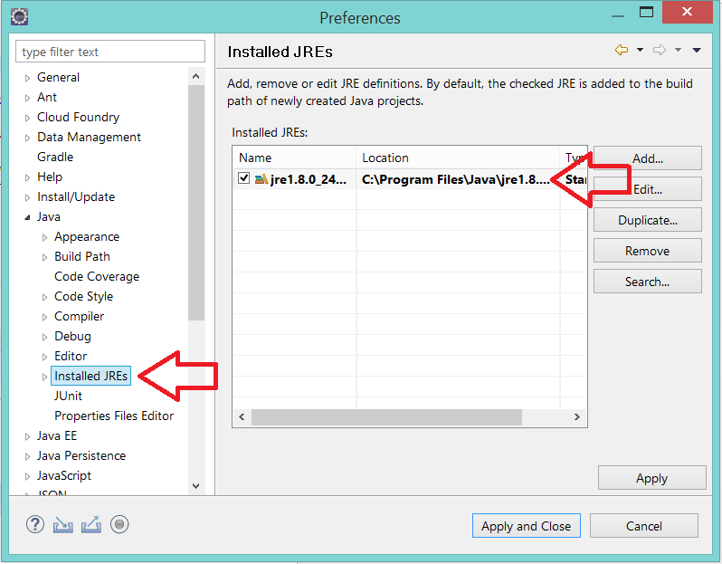

1. Make sure the JRE is selected and hit the “Remove” button.

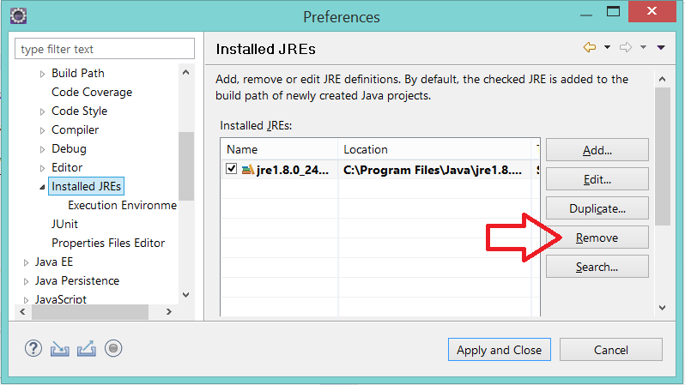

1. Once the JRE is removed, you will see an empty list. So now it’s time to set JDK up in our Eclipse.

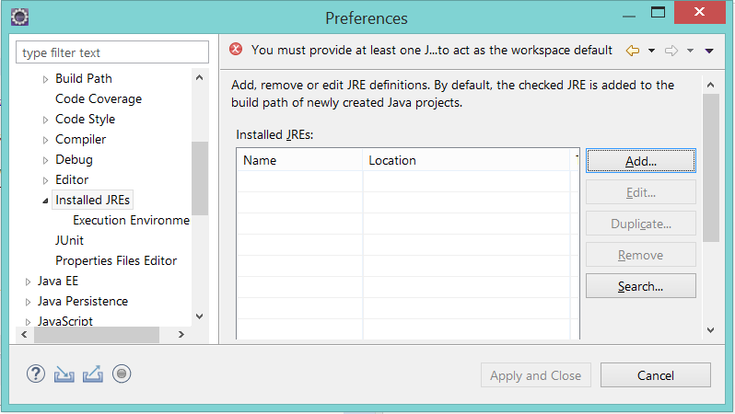

1. Hit the “Add” button.

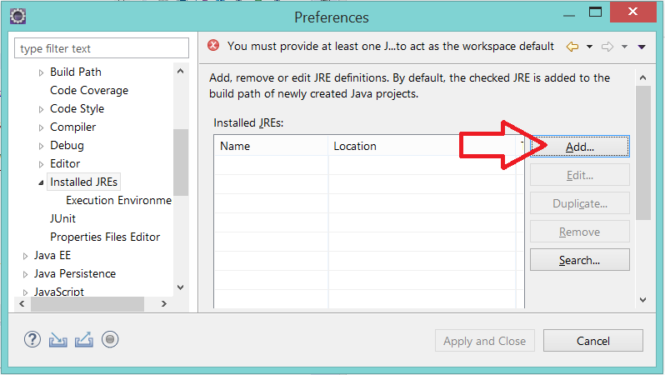

1. Select “Standard VM” and hit next.

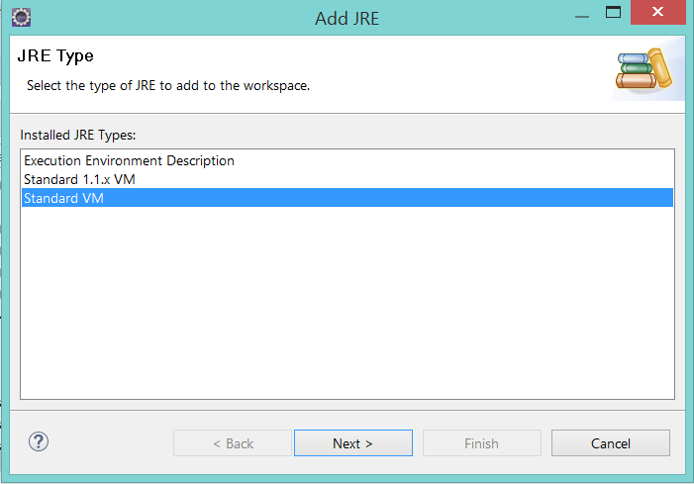

1. Hit the “Directory” button and provide the root folder of your JDK.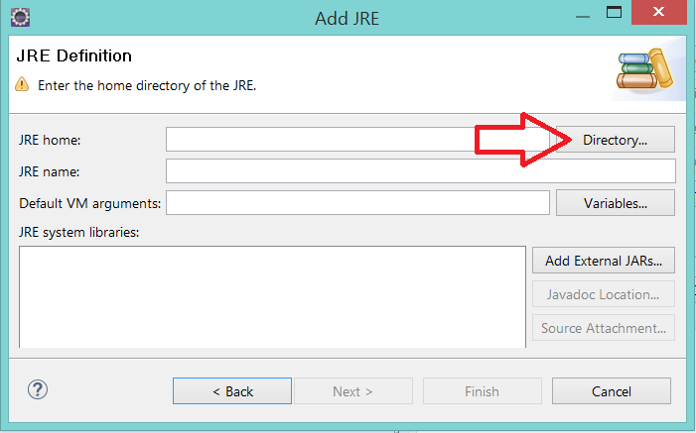
2. Your JDK should reside in *C:/Program Files/Java/jdk1.8.0.* Select the folder of your JDK. (Make sure you select the root folder of your JDK)

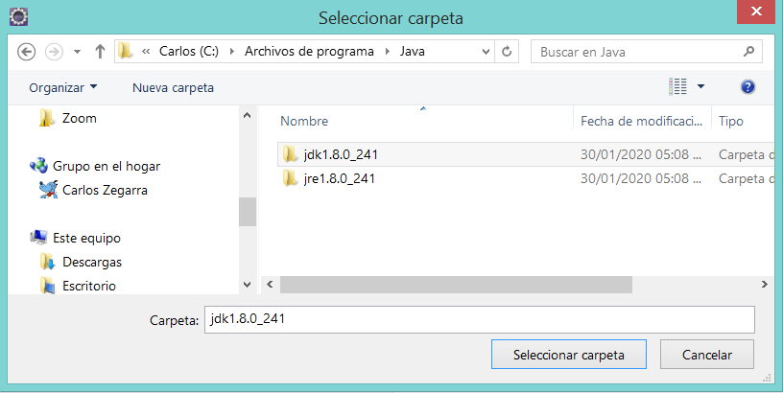

1. Eclipse will accept the new setup and will show the following window. Hit the “Finish” button.

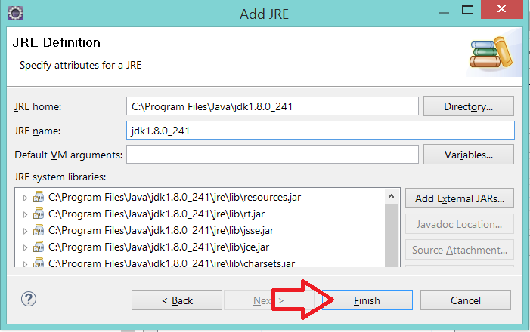

1. Finally, select JDK as your default Java definition by checking the checkbox and hitting the “Apply and Close” button. Now you are all set!

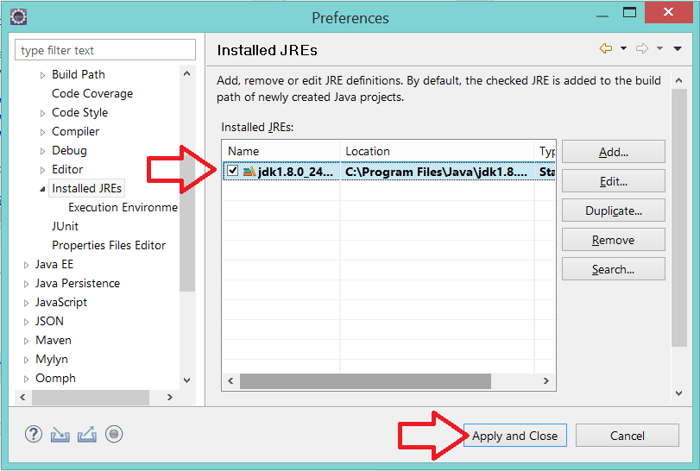

//End